Linux commands

Date: display date

Clear: clear screen

History: history of commands

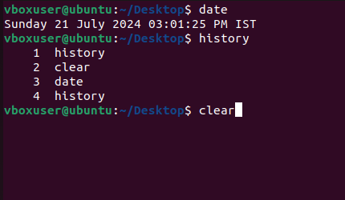

mkdir: create new directory

ls: list which are available

Il: long list with details

rm -rf: delete directory

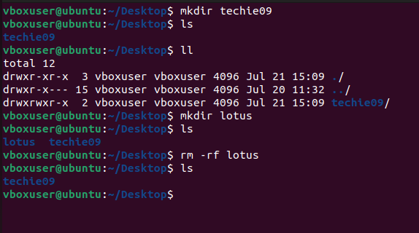

cd: enter into new directory

pwd: present work directory

cd .. : change directory one step

cd ../.. : change directory two steps

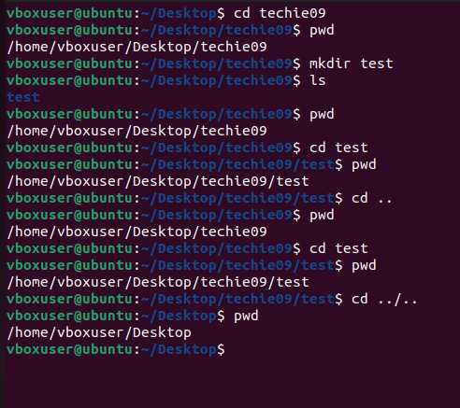

Mkdir -p a/b/c: create folder under folder

Rm -rf \*: delete everything

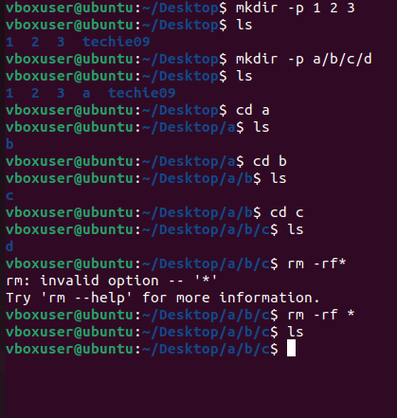

Touch: create file with zero bytes

vi,vim,nano: create a file and edit the file

i: go to insert mode

:wq! : to save context in file

:q : quit with out saving context in file

cat: read the file

rm : to delete file

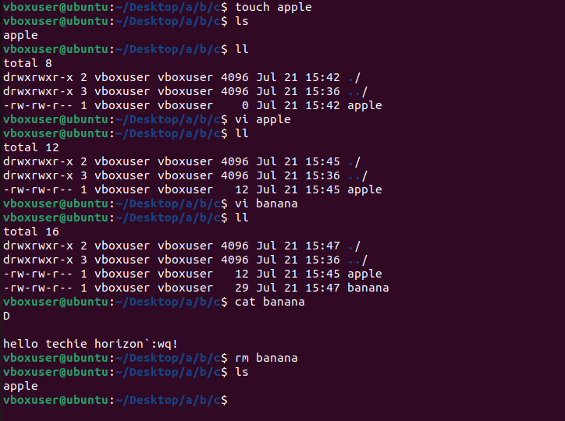

cp: copy file

mv: move file or rename file

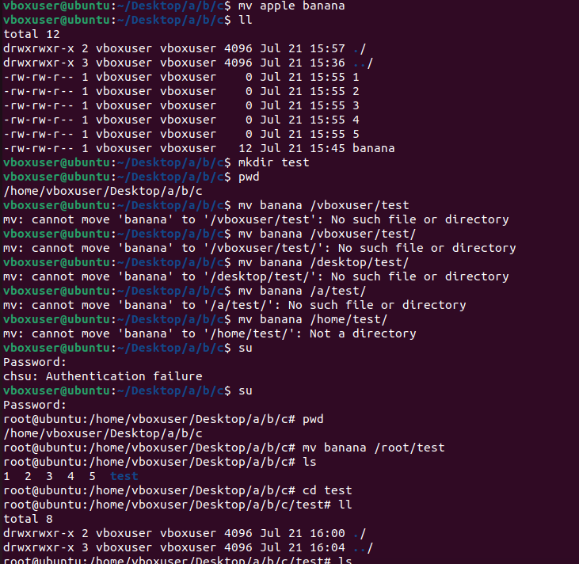

echo : same out put

>: store one out put a time

>>: store out put with out over ridding

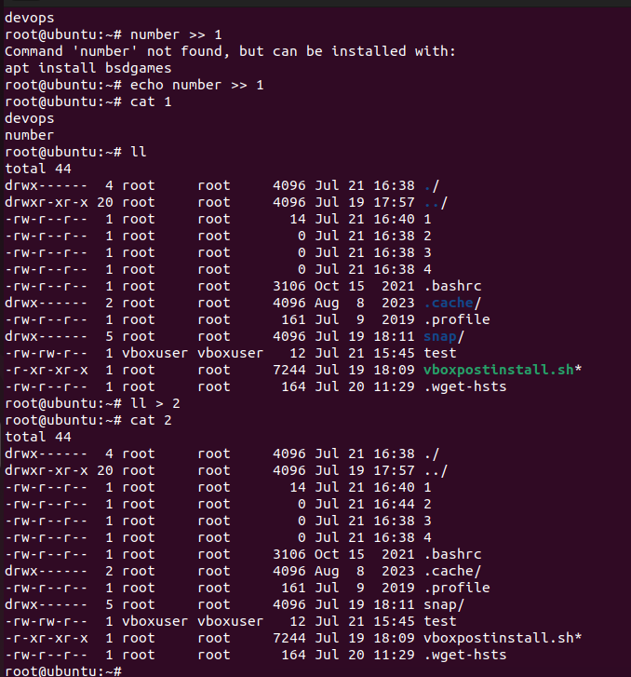

Head -3 <file name> : top 3 lines

Tail -2 <file name>: bottom 2 lines

Wc <file name> : word count

wc -l : lines count

grep : help to search key word in file

grep -i : I case sensitive

find / -name : search for a file

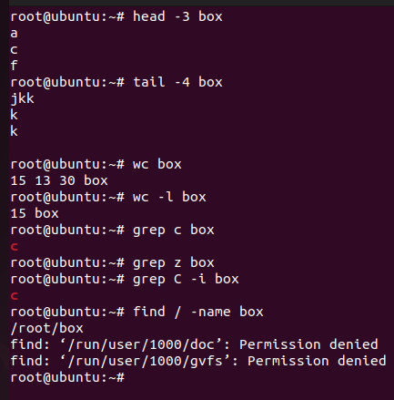

| : help to capture the input , multiple commands

/ : root directory

~: home directory

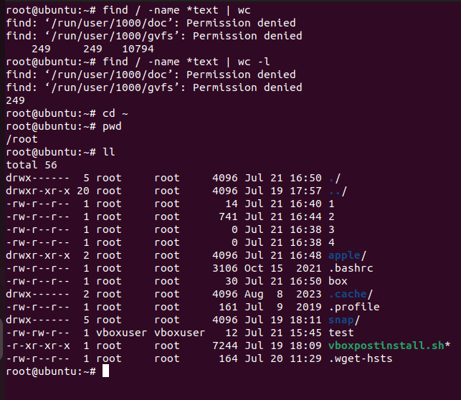

Find /-name os-realease - file of os

Cat /-name os-realease : read os

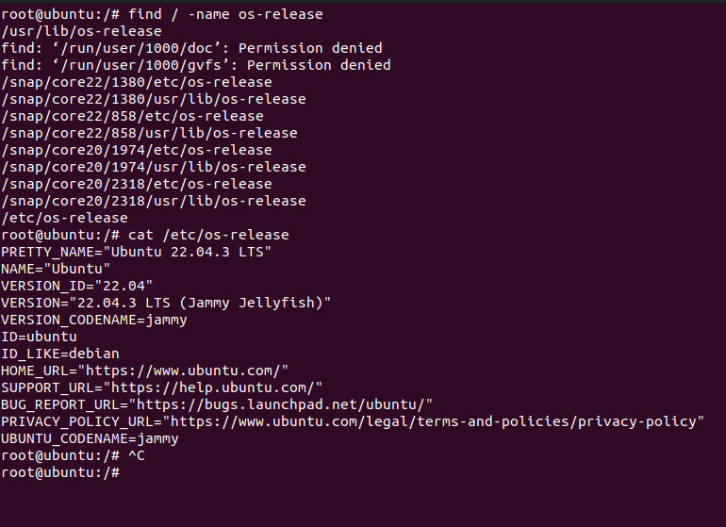

Cat/proc/cpuinfo : cpu information

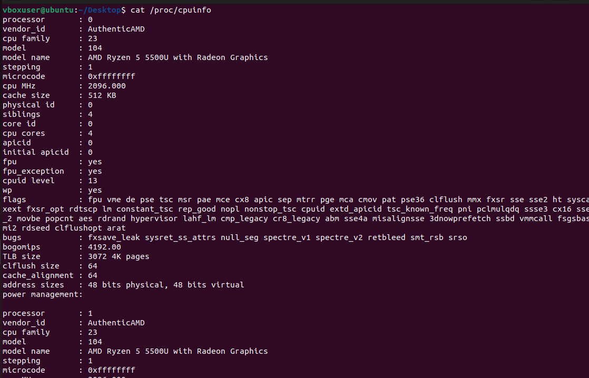

Cat /etc/passwd : number of users

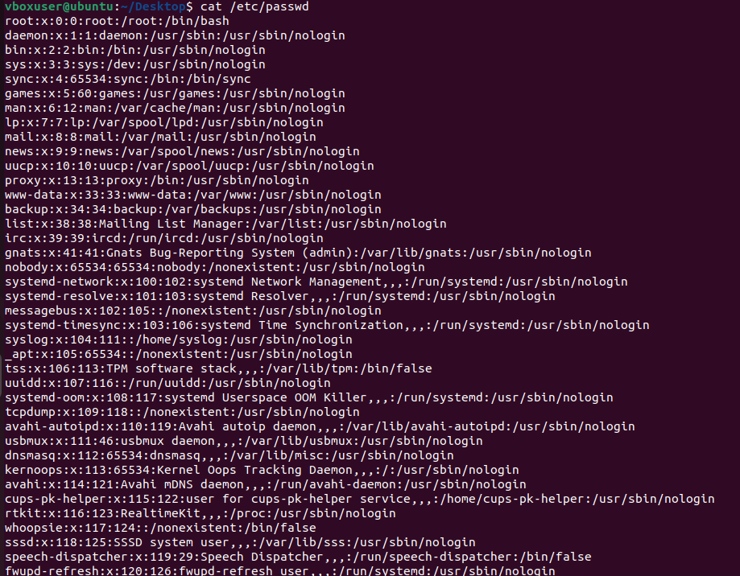

Useradd : add user

Cat /etc/passwd | grep gurram

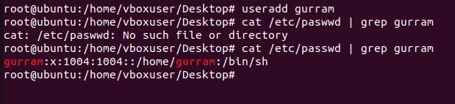

Passwd <username><hit enter>: change password for user

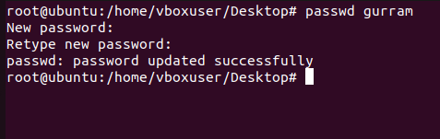

Chmod : change the file modes

R read owner

W write groups

X execute others

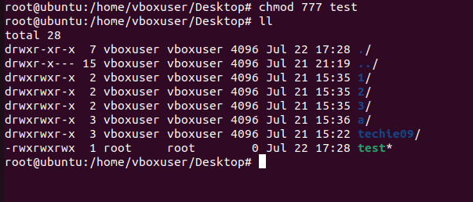

chown : change the owner

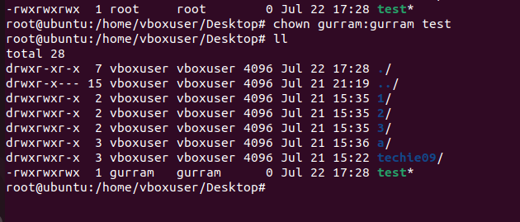

Scp : sending file from Windows to linus

$ scp -i Mckay123.pem manoj.pdf [ec2-user@16.171.253.128:/tmp/](mailto:ec2-user@16.171.253.128:/tmp/)

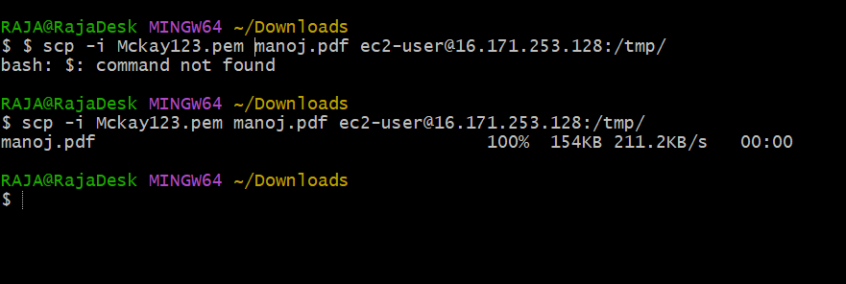

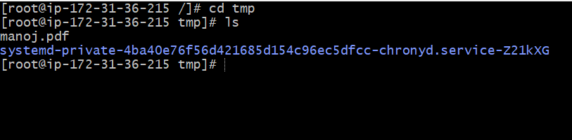

Sending file from linux to windows

